
Practical Report
For IoT Practical

Darshan Ramjiyani (DSP)
DOCS, KSKV Kachchh University

- 5.9 – Simple Analog and Digital Input

- Arduino Code:

const float referenceVolts = 5.0;
const int batteryPin = 0;
// the default reference on a 5-volt board
// battery is connected to analog pin 0
void setup()
{
Serial.begin(9600);
}
void loop()
{
int val = analogRead(batteryPin); // read the value from the sensor
float volts = (val / 1023.0) * referenceVolts; // calculate the ratio
Serial.println(volts); // print the value in volts
}

- Output / Circuit Diagram:
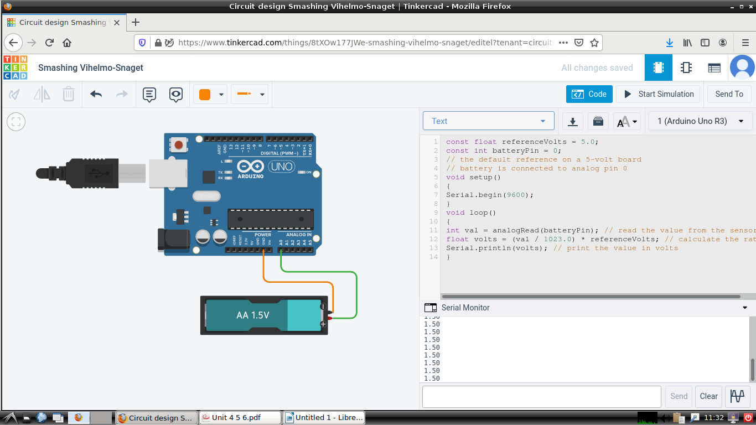
Darshan Ramjiyani

